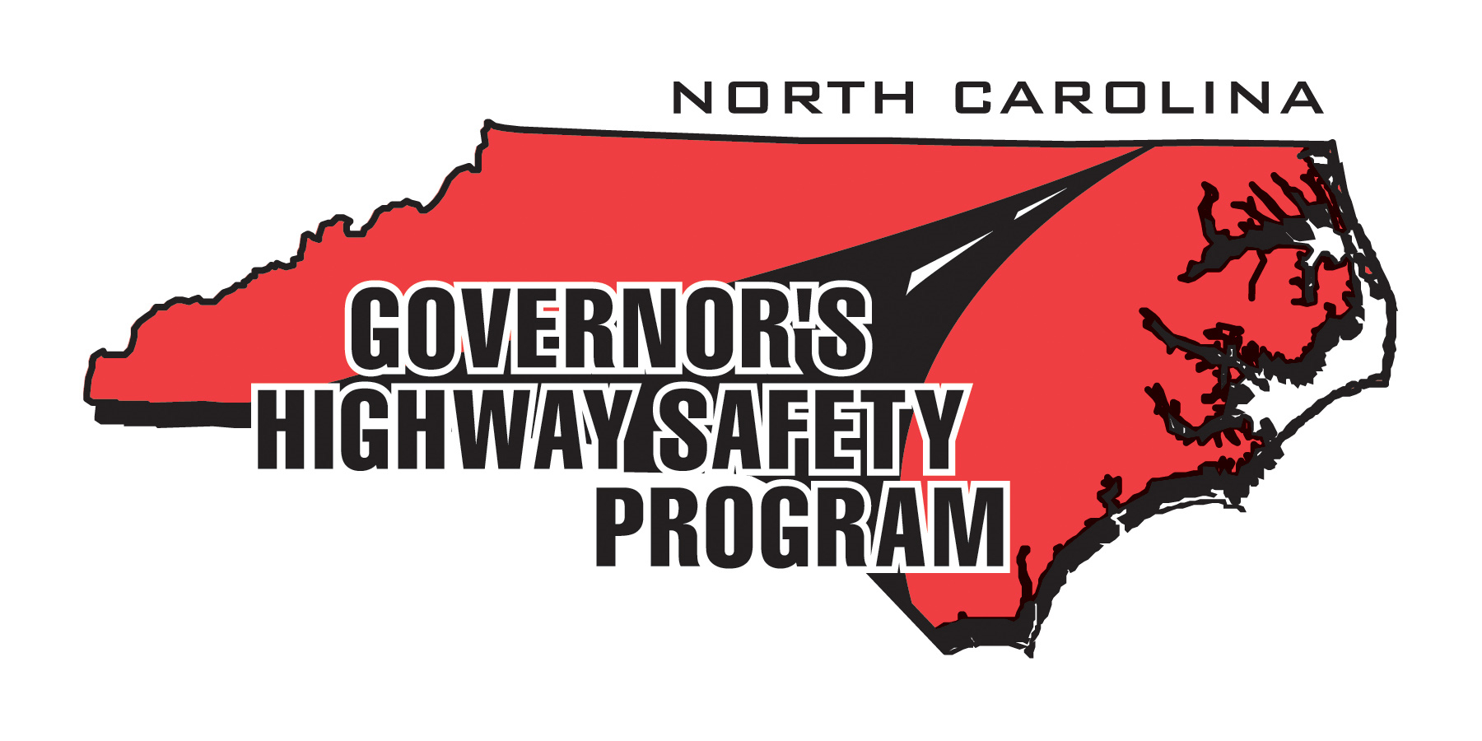
HIGHWAY SAFETY POSTER CONTEST

The contest runs from July 10, 2015 – October 5, 2015

Contest Rules

THEME: Highway Safety

Please read and follow all the rules carefully so that all posters/drawings will be eligible. The posters that BEST ILLUSTRATE HIGHWAY SAFETY will be selected as winners out of each of the three age groups.

Before the child begins drawing, we urge you to talk to them about best practices in highway safety around each one of the categories and provide examples of what you experience every day on the job.

Most importantly – HAVE FUN!

- Entry is open to all local and state law enforcement employees’ children, grandchildren, nieces and nephews between the ages of 5 and 17. There are three (3) age categories, four (4) highway safety categories to choose from, and four (4) first place winners will be selected from the following age groups totaling sixteen (16) winners:

Ages 5 - 9
Ages 10-13
Ages 14-17

Each category will have a recognized second, third, and honorable mention winner where possible.

- The poster drawing must relate to the theme “HIGHWAY SAFETY” and should illustrate one (1) of the four (4) highway safety categories. Encourage your children to be creative.

- The four (4) categories of highway safety are: (1) Driving While Impaired (Booze It & Lose It); (2) Unrestrained (Click It or Ticket); (3) Speeding (Obey the Sign or Pay the Fine); (4) Distracted Drivers (Texting, Passengers, Eating, etc.)

- THE FINISHED POSTER MUST BE NO LARGER THAN 11" x 14" and must be landscape position. Posters larger than 11” x 14” and in portrait position will be disqualified. All posters may be submitted as a PDF.

- Only one entry per child will be allowed. Parents/sponsors are limited to verbal assistance only. All drawings must be an individual effort and be free-hand originals. No traced pictures please.

- Each entry must include an official Highway Safety Poster Contest Entry Form. All information on the entry form must be filled out so we can contact the winners.

- ALL ENTRIES MUST BE EMAILED (.PDF) by 5:00 pm on OCTOBER 5, 2015 to jrbandy@ncdot.gov or POSTMARKED BY OCTOBER 2, 2015 to:

Jonathan Bandy
c/o Governor’s Highway Safety Program
1508 Mail Service Center
Raleigh, NC 27699

- The Governor’s Highway Safety Program is not responsible for entries that are delayed, lost, misdirected, incomplete, damaged, or destroyed.

- All entries become the property of the Governor’s Highway Safety Program once submitted.

- Criteria for judging will be based on creativity and how well the poster expresses the contest theme “Highway Safety.”

- Winning posters will be announced in October 7, 2015. A panel of independent judges will choose the winners.

- There will be a total of sixteen (16) first place winners and a second, third, and honorable mention where possible. These winners and their families will be invited to an art show at the NC State Capitol at the NC State Fairgrounds at Safety City during the state fair. Each winning poster will be on display for the duration of the state fair. Each winner’s state fair admission cost will be covered by the Governor’s Highway Safety Program.

If you have any questions please contact Jonathan Bandy at (919) 733-3083 or by email at jrbandy@ncdot.gov.

